НАЦІОНАЛЬНИЙ ТЕХНІЧНИЙ УНІВЕРСИТЕТ УКРАЇНИ
«КИЇВСЬКИЙ ПОЛІТЕХНІЧНИЙ ІНСТИТУТ»
ФАКУЛЬТЕТ ІНФОРМАТИКИ І ОБЧИСЛЮВАЛЬНОЇ ТЕХНІКИ
КАФЕДРА ОБЧИСЛЮВАЛЬНОЇ ТЕХНІКИ

Лабораторна робота №6
з дисципліни «Архітектура комп’ютерів 2»

Виконав:
студент ІІІ курсу
групи ІО-83
Крамар В.П.

Перевірив:
Нікольський С.

Київ 2020 р.

Посилання на репозиторій:
https://github.com/viktorkramar/AK2_Lab6

Виконання завдання Basic:

Код програми:

// SPDX-License-Identifier: GPL-2.0+

/*
* Copyright (c) 2017, GlobalLogic Ukraine LLC
* All rights reserved.
*
* Redistribution and use in source and binary forms, with or without
* modification, are permitted provided that the following conditions are met:
* 1. Redistributions of source code must retain the above copyright
* notice, this list of conditions and the following disclaimer.
* 2. Redistributions in binary form must reproduce the above copyright
* notice, this list of conditions and the following disclaimer in the
* documentation and/or other materials provided with the distribution.
* 3. All advertising materials mentioning features or use of this software
* must display the following acknowledgement:
* This product includes software developed by the GlobalLogic.
* 4. Neither the name of the GlobalLogic nor the
* names of its contributors may be used to endorse or promote products
* derived from this software without specific prior written permission.
*
* THIS SOFTWARE IS PROVIDED BY GLOBALLOGIC UKRAINE LLC ``AS IS`` AND ANY
* EXPRESS OR IMPLIED WARRANTIES, INCLUDING, BUT NOT LIMITED TO, THE IMPLIED
* WARRANTIES OF MERCHANTABILITY AND FITNESS FOR A PARTICULAR PURPOSE ARE
* DISCLAIMED. IN NO EVENT SHALL GLOBALLOGIC UKRAINE LLC BE LIABLE FOR ANY
* DIRECT, INDIRECT, INCIDENTAL, SPECIAL, EXEMPLARY, OR CONSEQUENTIAL DAMAGES
* (INCLUDING, BUT NOT LIMITED TO, PROCUREMENT OF SUBSTITUTE GOODS OR SERVICES;
* LOSS OF USE, DATA, OR PROFITS; OR BUSINESS INTERRUPTION) HOWEVER CAUSED AND
* ON ANY THEORY OF LIABILITY, WHETHER IN CONTRACT, STRICT LIABILITY, OR TORT
* (INCLUDING NEGLIGENCE OR OTHERWISE) ARISING IN ANY WAY OUT OF THE USE OF THIS
* SOFTWARE, EVEN IF ADVISED OF THE POSSIBILITY OF SUCH DAMAGE.
*/

#include <linux/init.h>
#include <linux/module.h>
#include <linux/moduleparam.h>
#include <linux/printk.h>
#include <linux/slab.h>

#include <linux/ktime.h>

struct personal_list_head {
struct personal_list_head *next;
ktime_t time;
};

MODULE_AUTHOR("Kramar Viktor IO-83");
MODULE_DESCRIPTION("Hello, world in Linux Kernel Training");
MODULE_LICENSE("Dual BSD/GPL");
are permitted provided that the following conditions are met:
* 1. Redistributio
static struct personal_list_head *header;

static uint count = 1;
module_param(count, uint, 0444);
MODULE_PARM_DESC(count, "Number of messages Hello, world");

static int __init hello_init(void)
{
uint i = 0;
struct personal_list_head *first, *second;

if (count == 0) {
pr_warn("WARNING!\nCounter = 0");
} else if (count >= 5 && count <= 10) {
pr_warn("WARNING!\nCounter between 5 and 10");
} else if (count > 10) {
pr_err("Invalid value!");
return -EINVAL;
}

header = kmalloc(sizeof(struct personal_list_head *), GFP_KERNEL);
first = header;
for (i = 0; i < count; i++) {
first->next = kmalloc(sizeof(struct personal_list_head), GFP_KERNEL);
first->time = ktime_get();
pr_info("Hello World!");
second = first;
first = first->next;
}
if (count != 0) {
kfree(second->next);
second->next = NULL;
}
pr_info("count: %d\n", count);
return 0;
}

static void __exit hello_exit(void)
{
struct personal_list_head *variable;
while (header != NULL && count != 0) {
variable = header;
pr_info("Time : %lld", variable->time);
header = variable->next;
kfree(variable);
}
if (count == 0)
pr_info("Time is 0 (print never used)");
pr_info("");
}

module_init(hello_init);
module_exit(hello_exit);

Результат виконання роботи:

modinfo:
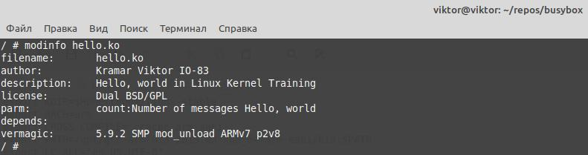
ismod з параметром 0 та rmmod:
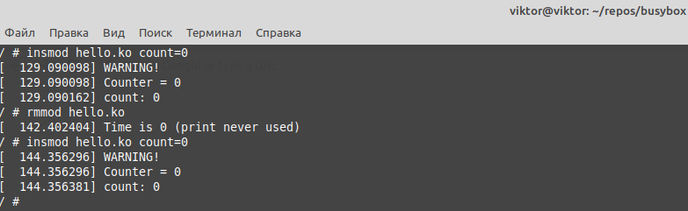

insmod з параметром 6 та rmmod:
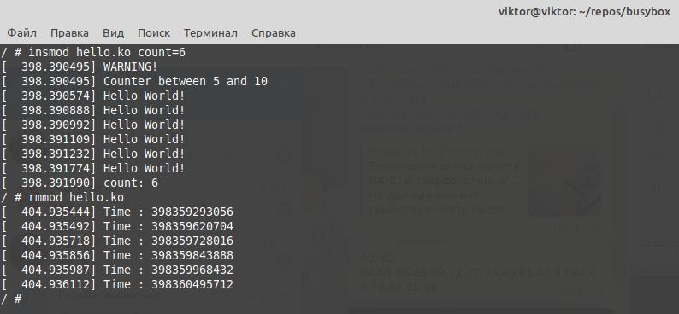
insmod з параметром 12 (невалідним) та rmmod:
